|  |  |  |
| --- | --- | --- |
| **S#** | **Work Product** | **Human Resource Responsible** |
| 1 | GANTT Chart | Farhan |
| 2 | Risk Plan | Abdul Mannan |
| 3 | WBS | Haider |
| 4 | COCOMO Estimates | Jawad |
| 5 | Resource List | Jawad |
| 6 | User Interface Design | Farhan, Jawad, Haider, Abdul Mannan |
| 7 | User Interface Coding | Farhan, Jawad, Haider, Abdul Mannan |
| 8 | Gameplay (Singleplayer & Multiplayer) | Farhan, Haider |
| 9 | User Management & Authentication & Database Storage | Jawad |
| 10 | Statistics & Reports | Abdul Mannan |
| 11 | Test Cases | Farhan, Jawad, Haider, Abdul Mannan |
| 12 | User Manual | Jawad, Farhan |

STATEMENT OF WORK

RESOURCE LIST

|  |  |  |  |  |
| --- | --- | --- | --- | --- |
| **Resource Name** | **Type** | **Initials** | **Max Utilization** | **Standard Rate** |
| Jawad Shahid | Work | J | 100% | PKR 2000/hour |
| Farhan Jafri | Work | F | 100% | PKR 2000/hour |
| Haider Khan | Work | H | 100% | PKR 2000/hour |
| Abdul Mannan | Work | M | 100% | PKR 2000/hour |
| Database Storage | Material | D | - | PKR 5000/month |
| Coding Environment (IDE) | Material | I | - | - |
| Web Hosting Service | Material | W | - | - |
| Testing Tools | Material | T | - | - |

COCOMO

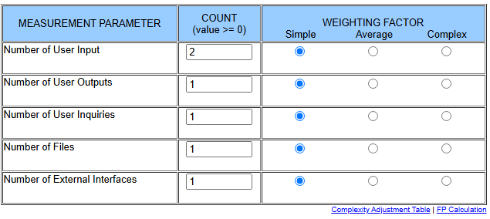

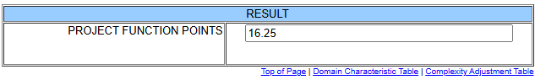

Language: JavaScript.

Num. SLOC per Function Point: 47 (According to <https://www.qsm.com/resources/function-point-languages-table>)

SLOC = 16.25*47 = 764

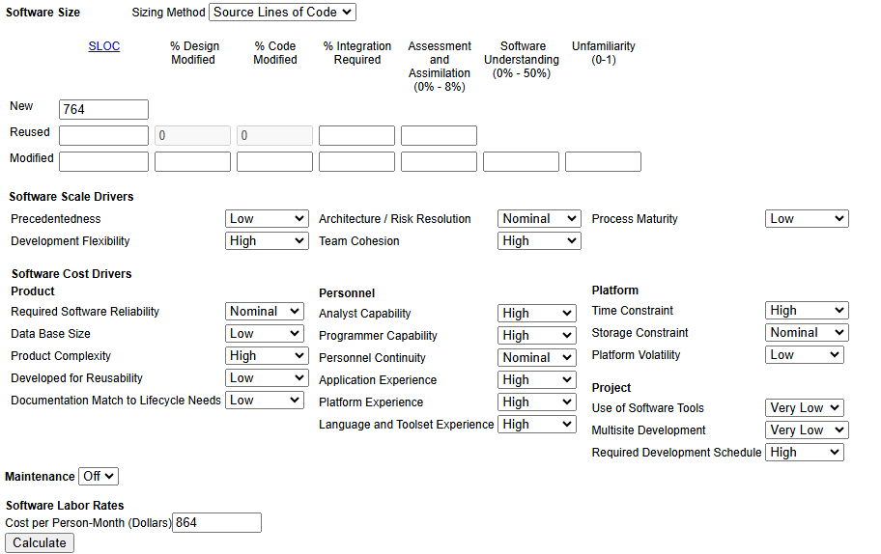

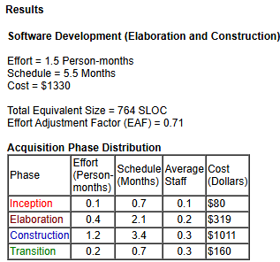

1 Person day = 4 hours

1 Person month = 30 days = 30 * 4 = 120 person-hours

Therefore 0.9 person months = 1.5 * 120 = 180 person-hours

Total Effort = 180 person-hours.

WBS

|  |  |  |  |  |  |  |  |
| --- | --- | --- | --- | --- | --- | --- | --- |
| **No.** | **Task Name** | **Duration** | **Start** | **Finish** | **Predecessor** | **Resource Names** | **Work** |
| 1 | notMonkeyType Game | 26 days | 27/10/24 | 21/11/24 | - | - | 180 hrs |
| 2 | User Management | 4 days | 27/10/24 | 31/10/24 | - | Jawad, Abdul Mannan | 24 hrs |
| 3 | Emulator | 4 days | 27/10/24 | 31/10/24 | - | Farhan, Haider | 24 hrs |
| 4 | Single Player Mode | 3 days | 1/11/24 | 3/11/24 | 3 | Farhan | 18 hrs |
| 5 | Multiplayer Mode | 4 days | 4/11/24 | 7/11/24 | 4 | Haider | 24 hrs |
| 6 | Navigation | 3 days | 8/11/24 | 10/11/24 | 2 | Jawad | 18 hrs |
| 7 | Database | 3 days | 11/11/24 | 13/11/24 | 2 | Jawad | 18 hrs |
| 8 | Change Game Mode | 2 days | 14/11/24 | 15/11/24 | 5 | Haider | 12 hrs |
| 9 | Game Statistics | 3 days | 16/11/24 | 18/11/24 | 7 | Abdul Mannan | 18 hrs |
| 10 | Email Verification | 2 days | 19/11/24 | 20/11/24 | 2 | Jawad | 12 hrs |
| 11 | Contact Us | 2 days | 19/11/24 | 20/11/24 | 10 | Farhan | 12 hrs |
| 12 | About Us | 2 days | 21/11/24 | 21/11/24 | - | Farhan | 12 hrs |
| 13 | Testing & User Manual | 2 days | 19/11/24 | 20/11/24 | 5,6,8,9,11,12 | Jawad, Farhan, Haider, Abdul Mannan | 12 hrs |

RISK PLAN

|  |  |  |  |  |  |
| --- | --- | --- | --- | --- | --- |
| **S#** | **Risk Description** | **Impact (1-10)** | **Probability (0-1)** | **Risk Exposure** | **Mitigation Strategy** |
| 1 | Delays in task completion due to dependencies | 8 | 0.7 | 5.6 | Break tasks into smaller sub-tasks and monitor progress regularly. |
| 2 | Lack of coordination between team members | 7 | 0.6 | 4.2 | Hold daily check-ins and maintain clear communication channels. |
| 3 | Technical issues with multiplayer feature | 9 | 0.5 | 4.5 | Allocate extra resources and time for multiplayer feature testing. |
| 4 | Bugs in the game logic causing delays | 8 | 0.8 | 6.4 | Prioritize testing and quality assurance to identify bugs early. |
| 5 | Integration issues between modules | 7 | 0.6 | 4.2 | Use version control, and integrate early and often. |
| 6 | Delay in feedback from stakeholders | 6 | 0.4 | 2.4 | Set clear deadlines and follow up regularly with stakeholders. |
| 7 | Unforeseen changes in project scope | 6 | 0.5 | 3.0 | Clearly define project scope at the beginning and use change control processes. |
| 8 | Team member unavailability due to personal reasons | 7 | 0.3 | 2.1 | Cross-train team members to handle multiple roles and tasks. |